This tutorial we will be working with prefabs and instantiating, instantiating is making a prefab appear, this useful if you wish to make items or objects appear in your game when you press a certain key for example pressing the space bar to drop a bomb or ball onto something.

1. Create a sphere to do this go to GameObject🡪 3D Object 🡪 Sphere. This will spawn a sphere object into unity for you to use.
2. To set up the object as a prefab first select your sphere and remove the sphere collider by right clicking and selecting remove component, then click add component and add in a 2D rigid body (to find this just type in rigid body in the search bar of the component section)
3. To make this item into a prefab, create a new folder in assets and name this folder prefab (this is to make things more organized) Now drag the object name from the hierarchy inside the prefab folder, the object will now be blue to show us that it is now a prefab so we can use it however we want. We also now delete the sphere object from the hierarchy as it’s no longer needed
4. Now create an empty game object do this by right clicking on hierarchy 🡪 Empty GameObject
5. Attach a new script to this empty game object, if you don’t have this set up first create a new folder called “scripts” (this is for organization purposes) then inside of ccripts right click and go to create 🡪 C# Script. Name this new script spawn and then drag it into the inspector of the empty game object to attach it
6. Now for the actual coding of the script the screenshot below will show you the entire script and it will have notes to explain what each part does.

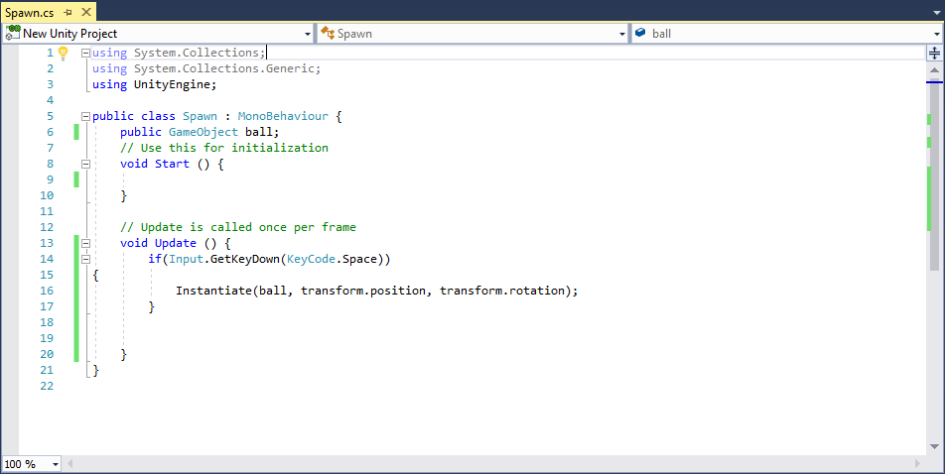

This is what spawns in the item, instantiate spawns the item in this case the ball, the transform parts tells us where it will spawn since nothing has been put in it will spawn at the empty game object

This line of codes is what tells the code that the player needs to press a certain key for it to activate in this case it’s the space button

This will allow us to place our prefab to act as our ball

1. Be sure to drag the prefab of the sphere to the ball section of the script, this prefab of the sphere is now the ball which will be spawned in.

You are now done! By pressing the space bar will the game is running it will spawn the prefab which will be the sphere you created.